Lecture 7.

Introduction to basic virology. The causative agents of acute respiratory viral infections (families of Orthomyxoviridae, Paramyxoviridae, Adenoviridae, Coronaviridae, Rhinovirus genus) and smallpox (Poxviridae family)

The purpose of the lecture: Morpho-biological characteristics of viruses that cause acute respiratory viral infections (Orthomyxoviridae, Paramyxoviridae, Adenoviridae and Coronaviridae, Rhinovirus genus) and smallpox (Poxviridae family), the pathogenesis, clinical signs, microbiological diagnosis, treatment and prevention principles of the diseases they cause.

Lecture plan:
1. Introduction to specific virology
2. Viruses that cause acute respiratory infections
3. Orthomyxoviridae family. General features, classification.
- Influenza viruses. Virion structure, structural features, cultivation, resistance. Influenza virus antigens. Classification of influenza A viruses by neuraminidase and hemagglutinin, antigen variability, ecology. Pathogenesis of influenza. Complicating effects of bacterial flora, immunity, microbiological diagnostics. Principles of specific treatment and prevention (vaccines, immunoglobulin, interferon, chemicals)
4. Paramyxoviridae family. General features, classification. Structure and chemical composition of virion, cultivation. Hemolysis, hemagglutination and hemadsorption properties. Resistance.
- Parainfluenza viruses, their role in human pathology, features of immunity
- Mumps virus, cultivation. Pathogenicity features. Immunity. Specific prevention.
- Respiratory syncytial viruses, cultivation. Pathogenicity features. Immunity.
- Morbillivirus genus. Measles virus. Pathogenicity features. Immunity. Semi-acute sclerosing panencephalitis. Microbiological diagnosis, specific prophylaxis.
5. Adenoviridae family, classification. Virion structure, cultivation, sustainability. Serotypes, pathogenicity features. Persistence. Microbiological diagnosis
6. Coronaviridae family, classification. Virion structure, serotypes, cultivation problems, pathogenicity features. Severe acute respiratory syndrome (SARS), COVID-19 infection.
7. Rhinovirus genus. Human pathogenicity
8. Poxviridae family, classification. Virion structure, cultivation, sustainability. Monkeypox virus. Pathogenicity features. Microbiological diagnosis.
Determinants of Viral Disease
Nature of the Disease-Target tissue, Portal of entry of virus, Access of virus to target tissue, Tissue tropism of virus, Permissiveness of cells for viral replication, Pathogenic activity (strain specific)
Severity of Disease
Cytopathic ability of virus
Virus inoculum size
Immune status (naive or immunized)
Competence of the immune system
Immunopathology
Length of time before resolution of infection
General health of the person
Nutrition
Other diseases influencing immune status
Genetic makeup of the person
Age
1 (A) Stages of viral infection. The virus is released from one person, is acquired by another, replicates, and initiates a primary infection at the site of acquisition. Depending on the virus, it may then spread to other body sites and finally to a target tissue characteristic of the disease. (B) The cycle starts with acquisition, as indicated, and proceeds until the release of new virus. The thickness of the arrow denotes the degree to which the original virus inoculum is amplified on replication. The boxes indicate a site or cause of symptoms. (C) Time course of viral infection. The time course of symptoms and the immune response correlate with the stage of viral infection and depend on whether the virus causes symptoms at the primary site or only after dissemination to another (secondary) site. CMV, Cytomegalovirus; HBV, hepatitis B virus; HIV, human immunodeficiency virus.
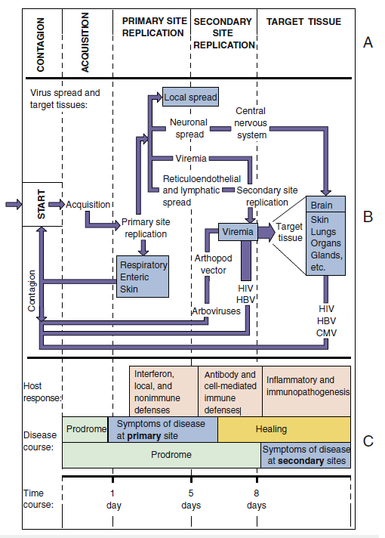

Viral Transmission
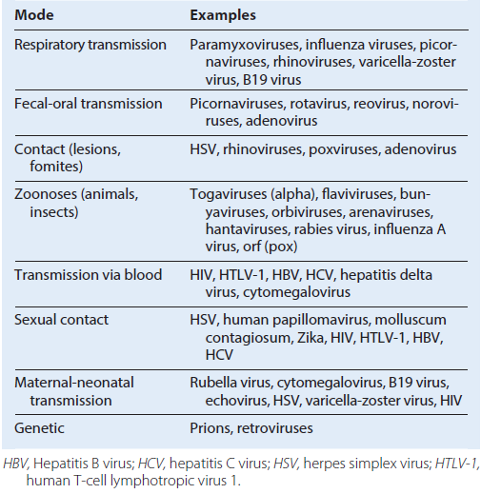

Mechanisms of Viral Transmission b
Aerosols
Food, water
Fomites (e.g., tissues, clothes)
Direct contact with secretions (e.g., saliva, semen)
Sexual contact, birth
Blood transfusion or organ transplant
Zoonoses (animals, insects [arboviruses])
Genetic (vertical) (e.g., retroviruses)
Disease and Viral Factors That Promote Transmission
Stability of virion in response to environment (e.g., drying, detergents, temperature)
Replication and secretion of virus into transmissible aerosols and secretions (e.g., saliva, semen)
Asymptomatic transmission
Transience or ineffectiveness of immune response to control reinfection or recurrence
Risk Factors
Age
Health
Immune status
Occupation: contact with agent or vector
Travel history
Lifestyle
Children in day-care centers
Sexual activity
Critical Community Size
Seronegative, susceptible people
Geography and Season
Presence of cofactors or vectors in the environment
Habitat and season for arthropod vectors (mosquitoes)
School session: close proximity and crowding
Home-heating season
Modes of Control
Quarantine
Elimination of the vector
Immunization/vaccination
Treatment
Education

Oral and Respiratory Diseases
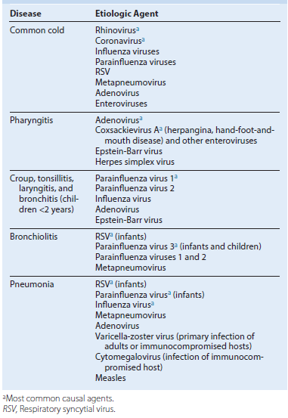

Viral Exanthems
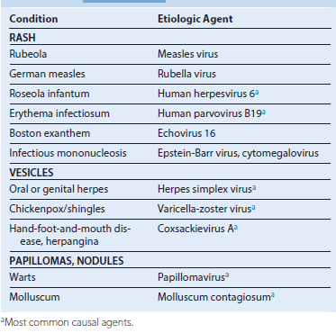
Gastrointestinal Viruses
Infants
Rotavirus Aa
Adenovirus 40, 41
Coxsackievirus A24
Infants, Children, and Adults
Norwalk virusa
Calicivirus
Astrovirus
Rotavirus A and
Viral Hemorrhagic Fevers
Yellow fever virus
Dengue viruses
Hantavirus
Ebola virus
Marburg virus
Lassa fever virus

Infections of Organs and Tissues
Liver
Hepatitis A,“a”2 B,“a” C,“a” G, D, and E viruses
Yellow fever virus
Epstein-Barr virus
Hepatitis in the neonate or immunocompromised person:
Cytomegalovirus
Herpes simplex virus
Varicella-zoster virus
Rubella virus (congenital rubella syndrome)
Heart
Coxsackievirus B
Kidney
Cytomegalovirus
BK papillomavirus
Muscle
Coxsackievirus B (pleurodynia)
Glands
Cytomegalovirus
Mumps virus
Coxsackievirus B
Eye
Herpes simplex virusa
Adenovirusa
Measles virus
Rubella virus
Enterovirus 70
Coxsackievirus A24

Central Nervous System Infections
Meningitis
Enteroviruses
Echoviruses
Coxsackievirusa
Poliovirus
Herpes simplex virus 2a
Adenovirus
Mumps virus
Lymphocytic choriomeningitis virus
Arboencephalitis viruses
Paralysis
Poliovirus
Enteroviruses D68, 70 and 71
Coxsackievirus A and A16
West Nile virus
Encephalitis
Herpes simplex virus 1a
Varicella-zoster virus
Arboencephalitis viruses a
Rabies virus
Coxsackieviruses A and B
Polioviruses
Postinfectious Encephalitis (Immune Mediated)
Measles virus
Mumps virus
Rubella virus
Varicella-zoster virus
Influenza viruses
Other
JC virus (progressive multifocal leukoencephalopathy [in immunosuppressed
people])
Measles variant (subacute sclerosing panencephalitis)
Prions (spongiform encephalopathy)
Human immunodeficiency virus (AIDS dementia)
Human T-cell lymphotropic virus 1 (tropical spastic paraparesis)
Viruses Transmitted in Blood
Hepatitis B, C, G, D
Human immunodeficiency virus
Human T-cell lymphotropic virus 1
Cytomegalovirus
Epstein-Barr virus
West Nile encephalitis virus
Sexually Transmitted Viruses
Human papillomavirus 6, 11, 42
Human papillomavirus 16, 18, 31, 45, and others (high risk for human
cervical carcinoma)
Herpes simplex virus (HSV-1 and HSV-2)
Cytomegalovirus
Hepatitis B, C, and D viruses
Human immunodeficiency virus
Human T-cell lymphotropic virus 1
Zika virus
Screening of the Blood Supply
HIV-1 and HIV-2
Hepatitis B virus
Hepatitis C virus
Human T-cell lymphotropic virus 1 and 2
West Nile encephalitis virus
Treponema pallidum (syphilis)a
a-Other than bacterial growth, Treponema pallidum is the only nonviral microbe assayed.

Arboviruses and Zoonoses
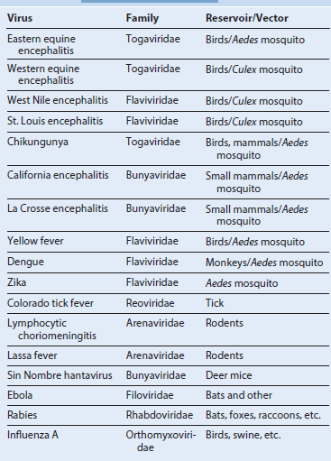

ORTHOMYXOVIRUSES
Trigger Words
Aerosols, envelope, segmented genome/reassortment, hemagglutinin, neuraminidase, antigenic drift (outbreaks), antigenic shift (pandemics), zoonosis
Biology, Virulence, and Disease
ᑏ Large size, enveloped, (−) segmented RNA genome
ᑏᑏ Encodes RNA-dependent RNA polymerase, replicates in nucleus (exception to the rule)
ᑏᑏ Each segment encodes one or two proteins
ᑏᑏ Mixed infection results in genetic mixing of segments: reassortment
ᑏᑏ Binds to sialic acid (HA glycoprotein) and encodes neuraminidase activity (NA glycoprotein)
ᑏᑏ Preexisting antibody can block disease
ᑏᑏ Cell-mediated immune response important for control but causes pathogenesis
ᑏᑏ Influenza A, not influenza B, is a zoonosis
ᑏᑏ Acute flulike symptoms caused by large cytokine release
ᑏᑏ Extensive destruction of ciliated epithelium
ᑏᑏ Pneumonia by influenza or secondary bacterial infection
Epidemiology
ᑏᑏ Transmitted by aerosols
ᑏᑏ Annual epidemics caused by mutations, pandemics caused by reassortment of genome segments between human and animal viruses
Diagnosis
ᑏᑏ Symptomatology, RT-PCR genome analysis of respiratory secretions, immunology tests (ELISA), hemagglutination and hemagglutination inhibition
Treatment, Prevention, and Control
ᑏᑏ Annual vaccine contains two influenza A and one or two influenza B strains: inactivated vaccines contain HA and NA, live attenuated nasal vaccine (for 2 to 49 year olds)
ᑏᑏ Neuraminidase, the M2 channel and the cap-dependent endonuclease are targets for antiviral drugs
Unique Features of the Influenza A and B Viruses
The enveloped virion has a genome of eight unique negativesense RNA nucleocapsid segments.
Hemagglutinin glycoprotein is the viral attachment protein and fusion protein; it elicits neutralizing, protective antibody responses.
Influenza transcribes and replicates its genome in the target cell nucleus but assembles and buds from the plasma membrane.
The polymerase uses capped cellular mRNA as primers for mRNA synthesis, and this is a target for baloxavir marboxil.
The antiviral drugs amantadine and rimantadine target the M2 (membrane) protein for influenza A only to inhibit the uncoating step.
The antiviral drugs zanamivir, oseltamivir, and peramivir inhibit the neuraminidase protein of influenza A and B.
The segmented genome promotes genetic diversity caused by mutation and reassortment of segments on infection with two different strains.
Influenza A infects humans, other mammals, and birds (zoonosis).

Products of Influenza Gene Segments
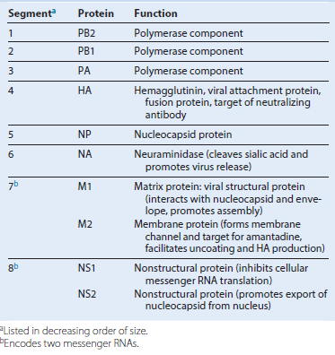

Replication of influenza A virus. After binding (1) to sialic acid–containing receptors, influenza is endocytosed and fuses (2) with the vesicle membrane. Unlike for most other ribonucleic acid (RNA) viruses, transcription (3) and replication (5) of the genome occur in the nucleus. Viral proteins are synthesized (4), helical ribonucleoprotein complex nucleocapsid segments form and associate (6) with the M1 protein–lined membranes containing M2 and the hemagglutinin (HA) and neuraminidase (NA) glycoproteins. The virus buds (7) from the plasma membrane and eventually kills the cell. (−), Negative sense; (+), positive sense; ER, endoplasmic reticulum; NP, nucleocapsid protein; NS1, NS2, nonstructural proteins 1 and 2; PA, PB1, PB2, polymerase components; polyA, polyadenylate.

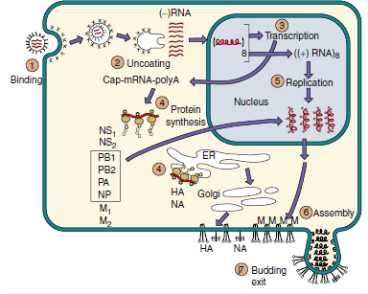

Pathogenesis of influenza A virus. The symptoms of influenza are caused by viral pathologic and immunopathologic effects, but the infection may promote secondary bacterial infection. CNS, Central nervous system.
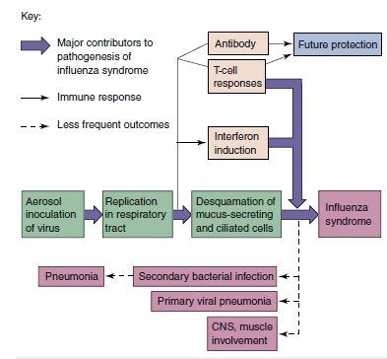
Disease Mechanisms of Influenza A and B Viruses
Virus infects the upper and lower respiratory tract.
Systemic symptoms are caused by the interferon and cytokine response to the virus. Local symptoms result from epithelial cell damage, including ciliated and mucus-secreting cells.
Interferon and cell-mediated immune responses (natural killer and T cells) are important for immune resolution and immunopathogenesis.
Infected people are predisposed to bacterial superinfection because of the loss of natural barriers and exposure of binding sites on epithelial cells.
Antibody is important for future protection against infection and is specific for defined epitopes on HA and NA proteins.
The HA and NA of influenza A virus can undergo major (reassortment: shift) and minor (mutation: drift) antigenic changes to ensure the presence of immunologically naive susceptible people.
Influenza B virus undergoes only minor antigenic changes.
Influenza Pandemics Resulting from Antigenic Shift
Year of Pandemic Influenza A Subtype
1918 - H1N1
1947 - H1N1
1957 - H2N2; Asian flu strain
1968 - H3N2; Hong Kong flu strain
1977 - H1N1; Russian
1997, 2003 - H5N1: China, avian
2009 - H1N1, swine flu

Time course of influenza A virus infection. The classic “flu syndrome” occurs early. Later, pneumonia may result from bacterial pathogenesis, viral pathogenesis, or immunopathogenesis.
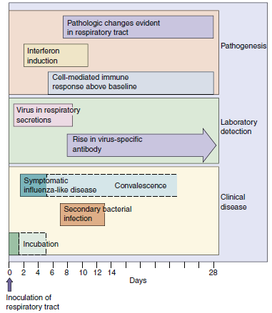
Generation of A/California/04/2009 (H1N1) pandemic swine flu by multiple reassortments of genomic segments of influenza A virus. The pandemic H1N1 virus arose from the mixing of a triple reassortment of avian, human, and swine viruses with two other swine viruses, each of which was also generated by reassortment between swine, human, and other influenza viruses. This new virus emerged in the spring of 2009 (out of season) in Mexico but was first identified in California.
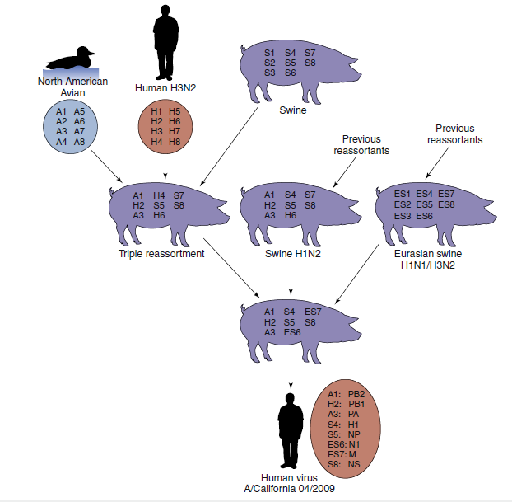

Epidemiology of Influenza A and B Viruses
Disease/Viral Factors
Virus has a large, enveloped virion that is easily inactivated by dryness, acid, and detergents.
Segmented genome facilitates major genetic changes, especially on hemagglutinin and neuraminidase proteins.
Influenza A infects many vertebrate species, including other mammals and birds.
Coinfection with animal and human strains of influenza A can generate very different virus strains by genetic reassortment.
Transmission of virus often precedes symptoms.
Transmission
Virus is spread by inhalation of small aerosol droplets expelled during talking, breathing, and coughing.
Virus likes a cool, less humid atmosphere (e.g., winter heating season).
Virus is extensively spread by schoolchildren.
Who Is at Risk?
Seronegative people
Adults: classic flu syndrome.
Children: asymptomatic to severe respiratory tract infections.
High-risk groups: elderly and immunocompromised people, people in nursing homes or with underlying cardiac or respiratory problems (including asthma sufferers and smokers).
Geography/Season
Worldwide occurrence. Epidemics are local; pandemics are worldwide.
Disease is more common in winter.
Modes of Control
Antiviral drugs have been approved for prophylaxis or early treatment. Killed and live vaccines contain predicted yearly strains of influenza A and B viruses.
Clinical Summary
Influenza A: A 70-year-old woman has rapid onset of fever with headache, myalgia, sore throat, and nonproductive cough. The disease progresses to pneumonia with bacterial involvement. There is no history of recent immunization with influenza A vaccine. Her husband is treated with amantadine or a neuraminidase inhibitor.
Diseases Associated With Influenza Virus Infection
Acute influenza infection in adults - Rapid onset of fever, malaise, myalgia, sore throat, and nonproductive cough
Acute influenza infection in children - Acute disease similar to that in adults but with higher fever, gastrointestinal tract symptoms (abdominal pain, vomiting), otitis media, myositis, and more frequent croup
Complications of influenza virus infection - Primary viral pneumonia, Secondary bacterial pneumonia, Myositis and cardiac involvement, Neurologic syndromes: Guillain-Barré syndrome, Encephalopathy, Encephalitis, Reye syndrome

Laboratory Diagnosis of Influenza Virus Infection
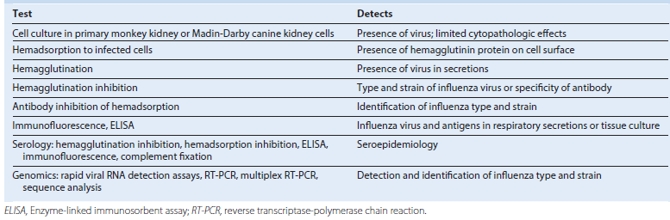

PARAMYXOVIRUSES
Trigger Words
ᑏ Fusion, syncytia, aerosols, envelope
ᑏᑏ Measles: cough, conjunctivitis, coryza, photophobia, Koplik spots, rash, fever, SSPE, postmeasles encephalitis
ᑏᑏ Mumps: parotitis, orchitis, aseptic meningitis
ᑏᑏ Parainfluenza: croup, barking seal, pneumonia
ᑏᑏ RSV: infant, pneumonia
Biology, Virulence, and Disease
ᑏᑏ Large size, enveloped, (−) RNA genome, fusion protein
ᑏᑏ Encodes RNA-dependent RNA polymerase, replicates in cytoplasm
ᑏᑏ Parainfluenza and mumps bind to sialic acid and encode neuraminidase activity (HN glycoprotein); measles and RSV glycoprotein bind to proteins
ᑏᑏ Fusion protein promotes entry and cell-cell fusion (syncytia)
ᑏᑏ Cell-mediated immune response essential for control but causes pathogenesis
ᑏᑏ Measles: maculopapular rash, high fever with cough, conjunctivitis, coryza, Koplik spots (small gray lesions in mouth); more severe if vitamin A deficient, giant cell pneumonia if T-cell deficient, postmeasles encephalitis, SSPE 5–7 years later caused by measles variant
ᑏᑏ Mumps: parotitis, orchitis, aseptic meningitis
ᑏᑏ Parainfluenza: common cold, croup, bronchitis
ᑏᑏ RSV: common cold, pneumonia, bronchiolitis, life-threatening for premature
infants
Epidemiology
ᑏᑏ Transmitted by aerosols
Diagnosis
ᑏᑏ Symptomatology, RT-PCR genome analysis of respiratory secretions
Treatment, Prevention, and Control
ᑏᑏ Live attenuated vaccine for measles and mumps; RSV: passive immunization for premature infants at high risk; aerosolized ribavirin RSV, Respiratory syncytial virus; RT-PCR, reverse transcriptase-polymerase chain reaction; SSPE, subacute sclerosing panencephalitis.

Paramyxoviridae
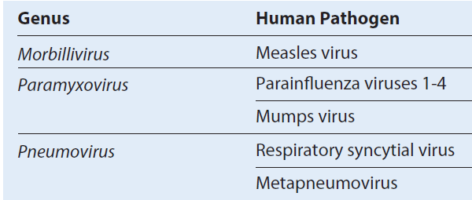

Unique Features of the Paramyxoviridae
Large virion consists of a negative-sense RNA genome in a helical nucleocapsid surrounded by an envelope.
The three genera can be distinguished by the activities of the viral attachment protein: HN of parainfluenza virus and mumps virus binds to sialic acid and red blood cells (hemagglutinin and neuraminidase activity), neuraminidase facilitates release from cell;
H of measles virus binds protein receptors and is also a hemagglutinin;
G of RSV binds to cells but is not a hemagglutinin.
Virus replicates in the cytoplasm.
Virions penetrate the cell by fusion with the plasma membrane and exit by budding from the plasma membrane without killing the cell.
Viruses induce cell-to-cell fusion, causing multinucleated giant cells (syncytia).
Cell-mediated immunity causes many of the symptoms but is essential for control of the infection.
Paramyxoviridae are transmitted in respiratory droplets and initiate infection in the respiratory tract.
Measles and mumps establish viremia and spread to other body sites.
Model of paramyxovirus. The helical nucleocapsid—consisting of negative-sense, single-stranded RNA and the polymerase (P), nucleoprotein (N), and large protein (L)—associates with the matrix (M) protein at the envelope membrane surface. The nucleocapsid contains RNA transcriptase activity. The envelope contains the viral attachment glycoprotein (hemagglutinin-neuraminidase [HN], hemagglutinin [H], or G-protein [G], depending on the virus) and the fusion (F) protein.
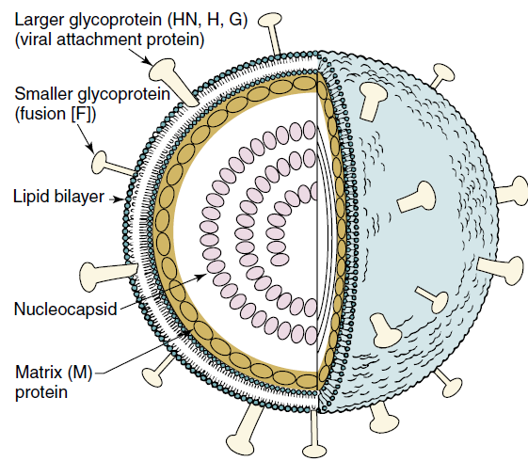

Major Viral-Encoded Proteins of Paramyxoviruses
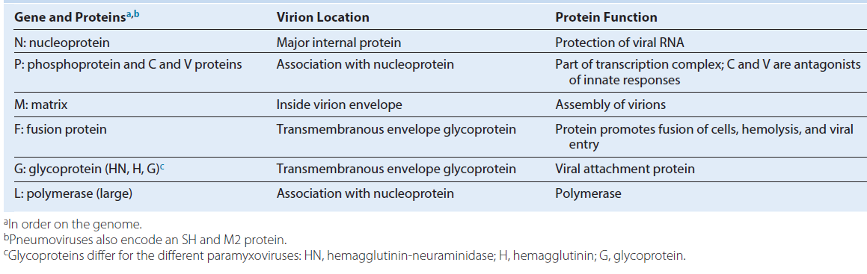
Mechanisms of spread of the measles virus within the body and the pathogenesis of measles. CMI, Cell-mediated immunity; CNS, central nervous system.
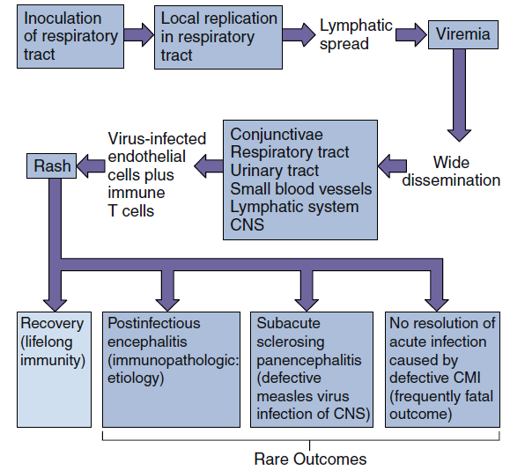
Replication of paramyxoviruses. The virus binds to glycolipids or proteins and fuses with the cell surface. Individual messenger RNAs (mRNAs) for each protein and a full-length template are transcribed from the genome. Replication occurs in the cytoplasm. Proteins associate with the new genome, and the nucleocapsid associates with matrix and glycoprotein-modified plasma membranes. The virus leaves the cell by budding. (−), Negative sense; (+), positive sense; ER, endoplasmic reticulum; RSV, respiratory syncytial virus. (Modified from Balows, A. et al., 1988. Laboratory Diagnosis of Infectious Diseases: Principles and Practice. Springer-Verlag, New York, NY.)
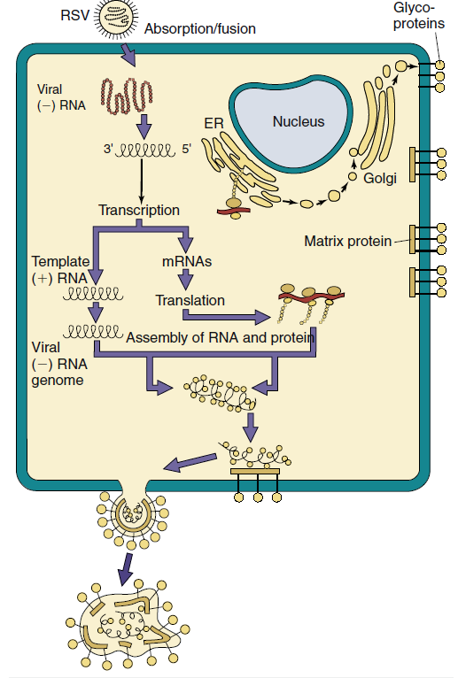
Disease Mechanisms of Measles Virus
Virus infects epithelial cells of respiratory tract.
Virus spreads systemically in lymphocytes by viremia.
Virus replicates in cells of conjunctivae, respiratory tract, urinary tract, lymphatic system, blood vessels, and CNS.
Rash is caused by T-cell response to virus-infected epithelial cells.
Virus causes immunosuppression.
Cell-mediated immunity is essential to control infection.
Sequelae in the CNS may result from immunopathogenesis (postinfectious measles encephalitis) or development of defective mutants (subacute sclerosing panencephalitis).
Time course of measles virus infection. Characteristic prodrome symptoms are cough, conjunctivitis, coryza, and photophobia (CCC and P), followed by the appearance of Koplik spots and rash. SSPE, Subacute sclerosing panencephalitis.
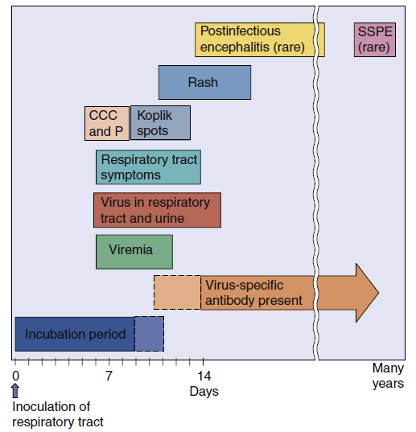
Epidemiology of Measles
Disease/Viral Factors
Virus has large enveloped virion that is easily inactivated by dryness and acid.
Contagion period precedes symptoms.
Very contagious with 95% infectivity rate.
Host range is limited to humans.
Only one serotype exists.
Immunity is lifelong.
Transmission
Inhalation of large-droplet aerosols.
Who Is at Risk?
Unvaccinated people, especially infants <1 year old.
Malnourished people, especially vitamin A deficient, who have more serious outcomes.
Immunocompromised people, who have more serious outcomes.
Geography/Season
Virus found worldwide.
Virus endemic from autumn to spring, possibly because of crowding indoors.
Modes of Control
Live attenuated vaccine (Schwartz or Moraten variants of Edmonston B strain) can be administered.
Immune serum globulin can be administered after exposure.
Clinical Consequences of Measles Virus Infection
Measles - Characteristic maculopapular rash, cough, conjunctivitis, coryza, photophobia, Koplik spots Complications: otitis media, croup, pneumonia, blindness, encephalitis
Atypical measles - More intense rash (most prominent in distal areas); possible vesicles, petechiae, purpura, or urticaria
Post measles encephalitis - Acute onset of headache, confusion, vomiting, possible coma after rash dissipates
Subacute sclerosing panencephalitis - Central nervous system manifestations (e.g., personality, behavior, and memory changes; myoclonic jerks; spasticity; blindness)
Measles-Mumps-Rubella Vaccine
Composition: live attenuated viruses
Measles: Schwartz or Moraten substrains of Edmonston B strain
Mumps: Jeryl Lynn strain
Rubella: RA/27-3 strain
Vaccination schedule: after 12 months of age and at age 4 to 6 years or before junior high school (12 years of age)
Efficiency: 95% lifelong immunization with a single dose
Disease Mechanisms of Parainfluenza Viruses
There are four serotypes of parainfluenza viruses.
Infection is limited to the respiratory tract; upper respiratory tract disease is most common, but significant disease can occur with lower respiratory tract infection.
Parainfluenza viruses do not cause viremia or become systemic.
Diseases include coldlike symptoms, bronchitis (inflammation of bronchial tubes), and croup (laryngotracheobronchitis).
Infection induces protective immunity of short duration.
Epidemiology of Parainfluenza Virus Infections
Disease/Viral Factors
Virus has a large enveloped virion that is easily inactivated by dryness and acid.
Contagion period precedes symptoms and may occur in absence of symptoms.
Host range is limited to humans.
Reinfection can occur later in life.
Transmission
Inhalation of large-droplet aerosols.
Who Is at Risk?
Children: at risk for mild disease or croup.
Adults: at risk for reinfection with milder symptoms.
Geography/Season
Virus is ubiquitous and worldwide.
Incidence is seasonal.
Modes of Control
There are no modes of control.
Disease Mechanisms of Mumps Virus
Virus infects epithelial cells of respiratory tract.
Virus spreads systemically by viremia.
Infection of parotid gland, testes, and central nervous system.
Principal symptom is swelling of parotid and other glands caused by inflammation.
Cell-mediated immunity is essential for control of infection and responsible for causing some of the symptoms.
Antibody is not sufficient because of the virus’ ability to spread cell to cell.

Mechanism of spread of mumps virus within the body.
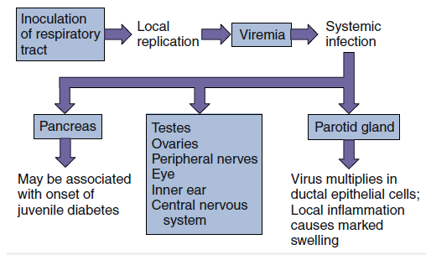

Time course of mumps virus infection. CSF, Cerebrospinal fluid.
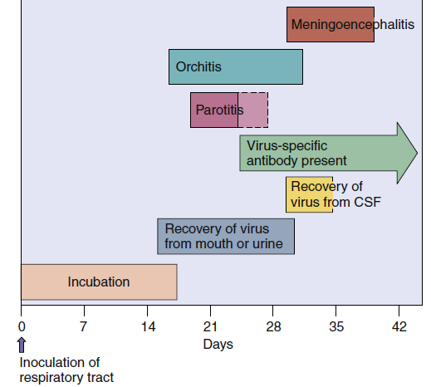

Epidemiology of Mumps Virus
Disease/Viral Factors
Virus has large enveloped virion that is easily inactivated by dryness and acid.
Contagion period precedes symptoms.
Virus may cause asymptomatic shedding.
Host range is limited to humans.
Only one serotype exists.
Immunity is lifelong.
Transmission
Inhalation of large-droplet aerosols.
Who Is at Risk?
Unvaccinated people, especially infants <1 year old.
Immunocompromised people, who have more serious outcomes.
Geography/Season
Virus is found worldwide.
Virus is endemic in late winter and early spring.
Modes of Control
Live attenuated vaccine (Jeryl Lynn strain) is part of measles mumps-rubella vaccine.
Disease Mechanisms of Respiratory Syncytial Virus
Virus causes localized infection of respiratory tract.
Virus does not cause viremia or systemic spread.
Pneumonia results from cytopathologic spread of virus (including syncytia).
Bronchiolitis is most likely mediated by the host’s immune response.
Narrow airways of young infants are readily obstructed by virus induced pathologic effects.
Maternal antibody is insufficient to protect infant from infection.
Natural infection does not prevent reinfection.
Epidemiology of Respiratory Syncytial Virus
Disease/Viral Factors
Virus has a large enveloped virion that is easily inactivated by dryness and acid.
Contagion period precedes symptoms and may occur in the absence of symptoms.
Host range is limited to humans.
Transmission
Inhalation of large-droplet aerosols.
Who Is at Risk?
Infants: lower respiratory tract infection (bronchiolitis and pneumonia).
Premature neonates: serious disease.
Children: spectrum of disease from mild to pneumonia.
Adults: reinfection with milder symptoms.
Immunocompromised, chronic heart and lung problems: serious disease.
Geography/Season
Virus is ubiquitous and found worldwide.
Incidence is seasonal.
Modes of Control
Immunoglobulin is available for infants at high risk.
Aerosol ribavirin is available for infants with serious disease.

Clinical Consequences of Respiratory Syncytial Virus Infection
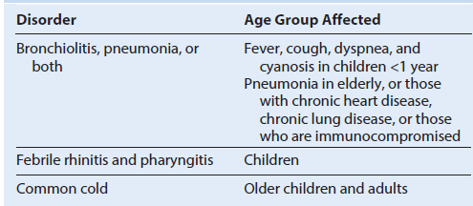

Clinical Summaries
Measles: An 18-year-old woman had been home for 10 days after a trip to Haiti when she developed a fever, cough, runny nose, and mild redness of her eyes. She now has a red, slightly raised rash over her face, trunk, and extremities. There are several 1-mm white lesions inside her mouth. She was never immunized for measles because of misinformation that an “egg allergy” would be a problem. The vaccine is not produced in eggs.
Mumps: A 30-year-old man returning from a trip to Russia experienced a 1- to 2-day period of headache and decreased appetite, followed by swelling over both sides of his jaw. The swelling extended from the bottom of the jaw to in front of the ear. Five days after the jaw swelling appeared, the patient began complaining of nausea and lower abdominal and testicular pain. He never received a booster immunization with the MMR vaccine.
Croup: An irritable 2-year-old toddler with little appetite has a sore throat, fever, and hoarse voice and coughs with the sound of a barking seal. A high-pitched noise (stridor) is heard on inhalation. Flaring of the nostrils indicates difficulty breathing.

ADENOVIRUSES
Trigger Words
Pharyngitis, conjunctivitis, atypical pneumonia, icosadeltahedral capsid
Biology, Virulence, and Disease
ᑏ Medium-sized icosadeltahedral capsid with fibers, linear DNA genome with terminal proteins
ᑏᑏ E1A and E1B proteins inactivate E6 and E7 to promote growth
ᑏᑏ Virus encodes polymerase
ᑏᑏ Capsid virus resistant to inactivation
ᑏᑏ Lytic virus
ᑏᑏ Causes pharyngitis, conjunctivitis, atypical pneumonia, infantile gastroenteritis, acute respiratory disease
ᑏᑏ Can be used as vector for making vaccines and gene therapy
Epidemiology
ᑏᑏ Transmitted by aerosols, direct contact, fecal-oral, contaminated swimming pools
Diagnosis
ᑏᑏ Immunological assays and PCR genome analysis
Treatment, Prevention, and Control
ᑏᑏ Adenovirus types 4 and 7 vaccine only for military

Illnesses Associated with Adenoviruses
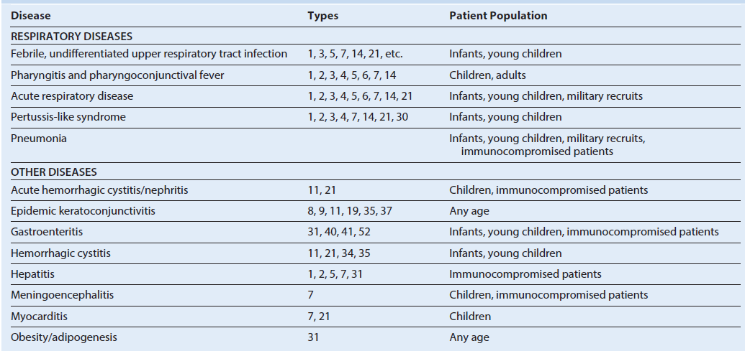

Unique Features of Adenovirus
Naked icosadeltahedral capsid has fibers (viral attachment proteins) at vertices.
Linear double-stranded genome has 5′ terminal proteins.
Synthesis of viral DNA polymerase activates a switch from early to late genes.
Virus encodes its own DNA polymerase and other proteins to facilitate growth and immune escape.
Human adenoviruses are grouped A through G by DNA homologies and by serotype (>55 human types).
Serotype is mainly a result of differences in the penton base and fiber protein, which determine the nature of tissue tropism and disease.
Virus causes lytic, persistent, and latent infections in humans, and some strains can immortalize certain animal cells.
Major Adenovirus Proteins
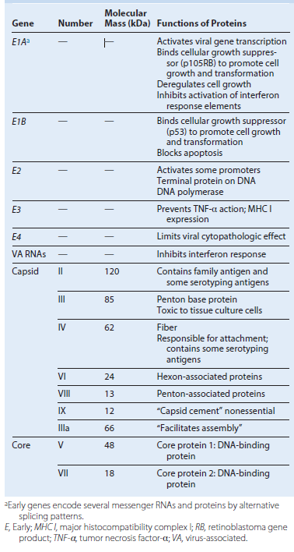

Simplified genome map of adenovirus type 2. Genes are transcribed from both strands (l and r) in opposite directions. The early genes are transcribed from four promoter sequences, and each generates several messenger RNAs by processing the primary RNA transcripts. This produces the full repertoire of viral proteins. The splicing pattern for only the E2 transcript is shown as an example. All of the late genes are transcribed from one promoter sequence. E, Early protein; L, late protein. 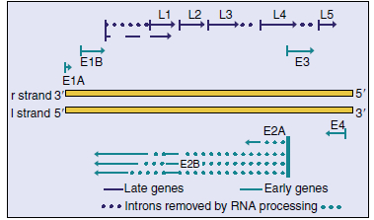
Disease Mechanisms of Adenoviruses
Virus is spread in aerosols, in fecal matter, and by close contact.
Fingers spread virus to eyes.
Virus infects mucoepithelial cells in the respiratory tract, gastrointestinal tract, and conjunctiva or cornea, causing cell damage directly.
Disease is determined by the tissue tropism of the specific group or serotype of the virus strain.
Virus persists in lymphoid tissue (e.g., tonsils, adenoids, Peyer patches).
Antibody is important for prophylaxis and resolution, but cellmediated immunity is also important.
Epidemiology of Adenoviruses
Disease/Viral Factors
Capsid virus is resistant to inactivation by gastrointestinal tract, drying, and detergents.
Disease symptoms may resemble those of other respiratory virus infections.
Virus may cause asymptomatic shedding.
Transmission
Direct contact, respiratory droplets and fecal matter on hands and fomites (e.g., towels, contaminated medical instruments), and
inadequately chlorinated swimming pools and ponds
Who Is at Risk?
Children <14 years of age
People in crowded areas (e.g., day-care centers, military training camps, swimming clubs)
Geography/Season
Virus is found worldwide.
There is no seasonal incidence.
Modes of Control
Live vaccine for serotypes 4 and 7 is available for military use.

Clinical Summaries
Pharyngoconjunctival fever: A 7-year-old student develops sudden onset of red eyes, sore throat, and a fever of 38.9° C (102° F).
Several children in the local elementary school have similar symptoms.
Gastroenteritis: An infant has diarrhea and is vomiting. Adenovirus serotype 41 is identified by polymerase chain reaction
analysis of stool for epidemiologic reasons.

Time course of adenovirus respiratory infection.
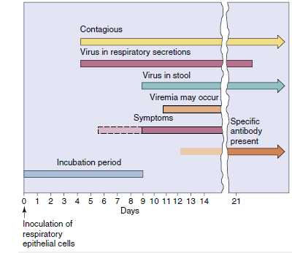

CORONAVIRUSES
Trigger Words
Common cold, SARS, MERS
Biology, Virulence, and Disease
ᑏ Medium size, enveloped, (+) RNA genome
ᑏᑏ Detergent resistant because of glycoprotein corona (exception to the rule for enveloped viruses)
ᑏᑏ Encodes RNA-dependent RNA polymerase, replicates in cytoplasm
ᑏᑏ Most coronaviruses cannot replicate at body temperature, restricted to upper respiratory tract
ᑏᑏ Most coronaviruses cause the common cold
ᑏᑏ MERS and SARS can replicate at 37° C and cause severe pneumonias
Epidemiology
ᑏᑏ Transmitted by aerosols, direct contact, fecal oral, contaminated swimming pools
Diagnosis
ᑏᑏ Symptomatology, RT-PCR genome analysis, or respiratory secretions
Treatment, Prevention, and Control
ᑏᑏ Quarantine for SARS, MERS
Model of a coronavirus. The viral nucleocapsid is a long, flexible helix composed of the positive-strand genomic RNA and many molecules of the phosphorylated nucleocapsid protein N. The viral envelope consists of a lipid bilayer derived from the intracellular membranes of the host cell, two or three viral glycoproteins (Spike [S], E, possibly hemagglutinin-esterase [HE]), and a matrix protein. (A, Courtesy Centers for Disease Control and Prevention, Atlanta, Georgia. B, Modified from Fields, B.F., Knipe, D.M., 1985. Virology. Raven, New York, NY.
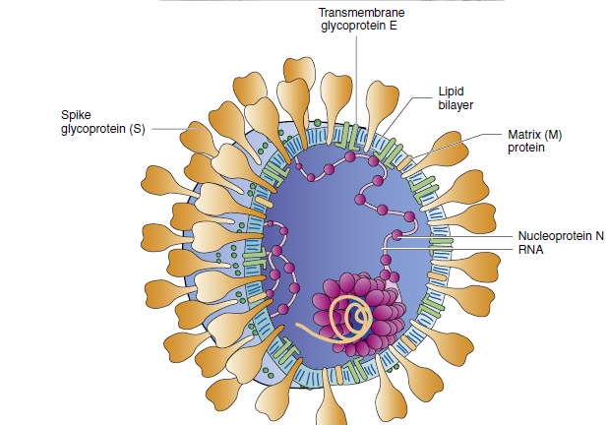

Unique Features of Coronaviruses
Virus has medium-sized virions with a solar corona–like appearance.
Single-stranded, positive-sense RNA genome is enclosed in an envelope containing the E2 viral attachment protein, E1 matrix protein, and N nucleocapsid protein.
Translation of genome occurs in two phases: (1) the early phase produces an RNA polymerase (L), and (2) the late phase, from a negative-sense RNA template, yields structural and nonstructural proteins.
Virus assembles at the rough endoplasmic reticulum.
Virus is difficult to isolate and grow in routine cell culture.
Major Human Coronavirus Proteins
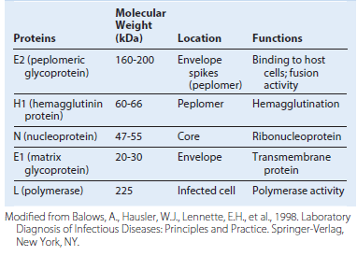
Replication of human coronaviruses. The E2 glycoprotein interacts with receptors on epithelial cells, the virus fuses or is endocytosed into the cell, and the genome is released into the cytoplasm. Protein synthesis is divided into early and late phases, similar to that in the togaviruses. The genome binds to ribosomes, and an RNA-dependent RNA polymerase is translated. This enzyme generates a full-length, negative-sense RNA template for the production of new virion genomes and six individual mRNAs for the other coronavirus proteins. The genome associates with rough endoplasmic reticulum membranes modified by virion proteins and buds into the lumen of the rough endoplasmic reticulum. Vesicles that contain the virus migrate to the cell membrane, and the virus is released by exocytosis. (Modified from Balows, A., Hausler, W.J., Lennette, E.H., et al., 1988. Laboratory Diagnosis of Infectious Diseases: Principles and Practice. Springer-Verlag, New York, NY.)
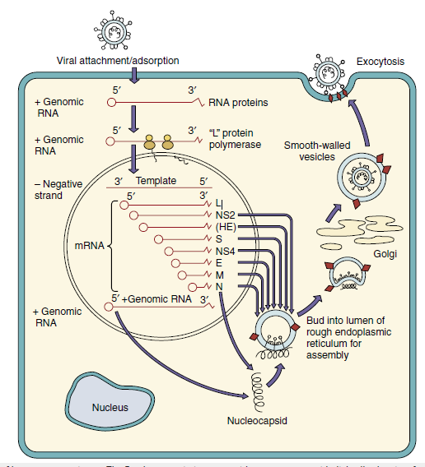

Disease Mechanisms of Human Coronaviruses
Human coronavirus infects and kills epithelial cells of the upper respiratory tract.
Virus replicates best at 33° C to 35° C; therefore it prefers the upper respiratory tract.
Reinfection occurs in the presence of serum antibodies.
The glycoprotein “corona” helps this enveloped virus survive the gastrointestinal tract.
SARS-CoV and MERS-CoV replicate at 37° C, kill cells and initiate inflammatory responses in the lung.
Coronaviruses
Common cold: A 25-year-old office worker develops a runny nose, mild cough, malaise, and a low-grade fever. A coworker has had similar symptoms for the past few days.
SARS: A 45-year-old businessman returned from a 2-week trip to China. Five days after returning home to the United States, he developed a fever of 101.5° F (38.6° C) and cough. Now he observes that it is harder to catch his breath.

PICORNAVIRUSES
Trigger Words
Polio: flaccid paralysis, major and minor disease, fecal-oral
Coxsackievirus A: vesicular diseases, meningitis; coxsackievirus B (body): pleurodynia, myocarditis
Other echovirus and enteroviruses: like coxsackievirus and hepatitis A virus
Rhinoviruses: common cold, acid labile, does not replicate above 33° C
Biology, Virulence, and Disease
ᑏ Small size, icosahedral capsid, positive RNA genome with terminal protein
ᑏᑏ Genome is sufficient for infection
ᑏᑏ Encodes RNA-dependent RNA polymerase, replicates in cytoplasm
(A)Cryoelectron microscopy computer-generated reconstruction of human rhinovirus 16. (B) Cryoelectron microscopy reconstruction of the interaction of a soluble form of intercellular adhesion molecule-1 (ICAM-1) with human rhinovirus 16. Note: There is one ICAM-1 per capsomere. (C) Structure of the human rhinovirus. (D) Binding of the ICAM-1 molecule within the canyon of the virion triggers the opening of the capsid for release of the genome into the cell. RNA, Ribonucleic acid; VP1, 2, 3, 4, viral protein 1, 2, 3, 4; VPg, viral protein genome-linked. (A and B, Courtesy Tim Baker, Purdue University, West Lafayette, Indiana.)
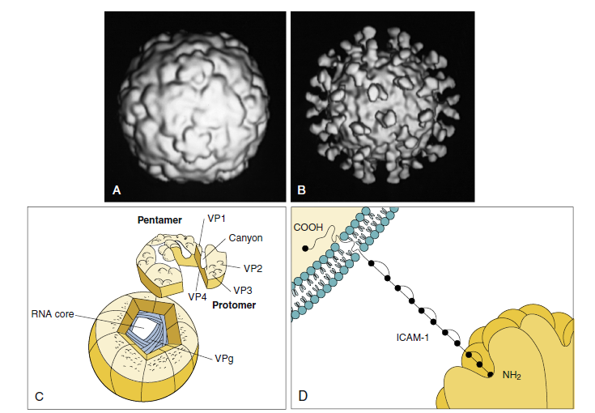

Structure of the picornavirus genome. The genome (7200 to 8400 bases) is translated as a polyprotein that is cleaved by viral-encoded proteases into individual proteins. Viral genes: VP1, 2, 3, 4, capsid proteins 1, 2, 3, 4; 2A cleaves eIF4g to inhibit host protein synthesis; 2B, 2C, 3A, 3B generate membrane-binding, vesicle-forming proteins that facilitate replication; 3B also encodes VPg genome-binding protein; 3Cpro, protease; RdRp, RNA-dependent RNA polymerase. (Redrawn from Whitton, J.L., Cornell, C.T., Feuer, R., 2005. Host and virus determinants of picornavirus pathogenesis and tropism. Nat. Rev. Microbiol. 3, 765–776.)
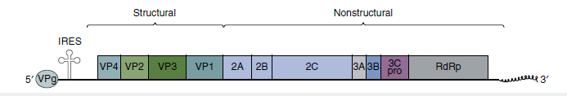
Epidemiology of Rhinovirus Infections
Disease/Viral Factors
Virion is resistant to drying and detergents
Multiple serotypes preclude prior immunity
Replication occurs at optimum temperature of 33° C and cooler temperatures
Transmission
Direct contact via infected hands and fomites
Inhalation of infectious droplets
Who Is at Risk?
Persons of all ages
Geography/Season
Virus found worldwide
Disease more common in early autumn and late spring
Modes of Control
Washing hands and disinfecting contaminated objects help prevent spread
Rhinovirus
Common cold: A 25-year-old office worker develops a runny nose, mild cough, and malaise with a low-grade fever. A coworker has had similar symptoms for the past few days.
Diagnosis - Immune assays (ELISA) or RT-PCR, genome analysis of blood, CSF, or other relevant sample
POXVIRUSES
Trigger Words
Molluscum, smallpox, zoonosis, vaccinia vaccine, cytoplasmic replication
Biology, Virulence, and Disease
ᑏ Very large, enveloped with complex morphology, linear DNA genome fused at ends, virus encodes DNAdependent RNA and DNA-dependent DNA polymerases
ᑏᑏ Cell-mediated immunity essential for control
ᑏᑏ Molluscum contagiosum stimulates cell growth to cause wartlike growth; only infects humans
ᑏᑏ Smallpox: lytic, only infects humans, vesicles appear all at once, bioterror agent
ᑏᑏVaccinia, orf: lytic viruses, zoonotic
Epidemiology
ᑏᑏ Smallpox transmitted by aerosols, direct contact; all others only by contact
Diagnosis
ᑏᑏ Polymerase chain reaction genome analysis of lesion fluid
Treatment, Prevention, and Control
ᑏᑏVaccinia virus as vaccine for smallpox
ᑏᑏ Quarantine
Unique Properties of Poxviruses
Largest, most complex viruses.
Have complex, oval- to brick-shaped morphology with internal structure.
Have a linear, double-stranded DNA genome with fused ends.
DNA viruses that replicate in the cytoplasm.
Encodes and carries all proteins necessary for mRNA synthesis.
Also encodes proteins for functions such as DNA synthesis, nucleotide scavenging, and immune escape mechanisms.
Assembled in inclusion bodies (Guarnieri bodies; factories), where it acquires its outer membranes.
Structure of the vaccinia virus. Within the virion, the core assumes the shape of a dumbbell because of the large lateral bodies. Virions have a double membrane; the “outer membrane” assembles around the core in the cytoplasm, and the virus leaves the cell by exocytosis or on cell lysis.
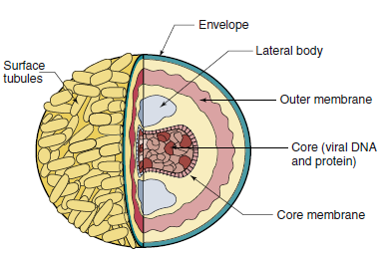

Replication of vaccinia virus. The core is released into the cytoplasm, where virion enzymes initiate transcription of early genes. A viral-encoded “uncoatase” enzyme then causes the release of DNA. Viral polymerase replicates the genome, and late transcription occurs. DNA and protein are assembled into cores within the core membrane. An outer membrane shrouds the core containing the lateral bodies and the enzymes required for infectivity. The virion is exocytosed or is released by cell lysis.
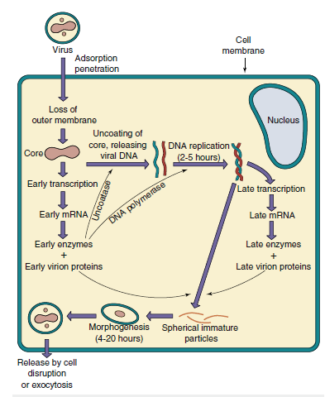

Disease Mechanisms of Poxvirus
Smallpox is initiated by respiratory tract infection and is spread mainly by the lymphatic system and cell-associated viremia.
Molluscum contagiosum and other poxviruses are transmitted by contact.
Virus may cause initial stimulation of cell growth and then cell lysis.
Virus encodes immune evasion mechanisms.
Cell-mediated immunity and humoral immunity are important for resolution.
Most poxviruses share antigenic determinants, allowing preparation of “safe” live vaccines from animal poxviruses.
Spread of smallpox within the body. The virus enters and replicates in the respiratory tract without causing symptoms. The virus infects macrophages, which enter the lymphatic system and carry the virus to regional lymph nodes. The virus then replicates and initiates a viremia, causing the infection to spread to the spleen, bone marrow, lymph nodes, liver, and all organs, followed by the skin (rash). A secondary viremia causes the development of additional lesions throughout the host, followed by death or recovery with or without sequelae. Recovery from smallpox was associated with prolonged immunity and lifelong protection.

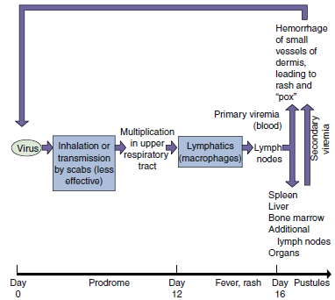

Properties of Natural Smallpox That Led to Its Eradication Viral Characteristics
Exclusive human host range (no animal reservoirs or vectors)
Single serotype (immunization protected against all infections)
Shares antigenic determinants with other pox viruses.
Disease Characteristics - Consistent disease presentation with visible pustules (identification of sources of contagion allowed quarantine and vaccination of contacts)
Vaccine- Immunization with animal poxviruses protects against smallpox Stable, inexpensive, and easy-to-administer vaccine Presence of scar, indicating successful vaccination
Public Health Service - Successful worldwide World Health Organization program combining vaccination and quarantine
Diseases Associated with Poxviruses
